OPERATING INSTRUCTIONS
NATIONAL TIME STAMP
330-220-7655
nationaltimestamp.com

RAPIDPRINT

DIVISION OF

BIDWELL INDUSTRIAL GROUP
2055 SOUTH MAIN STREET MIDDLETOWN,CT.06457

Rapidprint AR-E Time Stamp

Rapidprint ARL-E Time and Date Stamp

Rapidprint Service

Your RAPIDPRINT time stamp machine features an electronic stamping mechanism. This design ensures consistently clear imprints. Electronic components offer superior reliability and performance.

GENERAL INSTRUCTIONS
Check the current, voltage, and cycles as given on name plate and be certain that those specifications conform with the electrical power you intend using. Make a record of the serial number of this machine and the number given on the key for reference.
When ordering parts or making any inquiry be sure to give the serial number and the model designation, i.e. #205735; AR- E.

NOTE!
Generally it is wise to disconnect the machine from the wall receptacle whenever the top casting of the machine is going to be opened - (for wheel setting, changing ribbon, etc.) Always remember to reset the wheels to the correct time after such periods.

INDEX
Page No.

Diagram - Wheel Setting. 1
Instructions for Setting Printing Wheels 2
Instructions for Setting Analog Clock. 3
Instructions for Setting Digital Clock 4
How to Obtain Impressions 6
Diagram - Ribbon Installation 7
Instructions for Removing and Installing Ribbon 8
Installation Instructions for Paper Guide 9

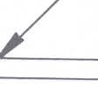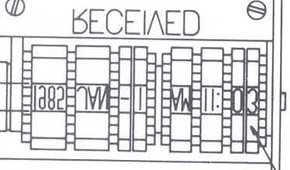
TOP CASTING
0
0
LINE OF PRINT

PRINTING WHEELS

DIAGRAM "A"

1

INSTRUCTIONS FOR SETTING PRINTING WHEELS

NOTE: Always unplug the time stamp before opening. With machine facing operator unlock and lift up top casting.
To set wheels to proper position, turn wheels down­ ward with a pencil or wooden stylus until they are in line. See diagram A.
The use of a metal stylus can damage the printing characters.

TIME STAMPS - The wheels operate automatically to the end of the month. Reset the date and month wheels at the first of each month and the year wheel on the first of each year.

DATE STAMPS - (without time) The wheels must be reset daily.

NUMBERING MACHINES - Only the first six wheels operates automatically. Additional wheels must be hand set. If a date section is included the date wheels must be reset daily.

2

ANALOG CLOCK

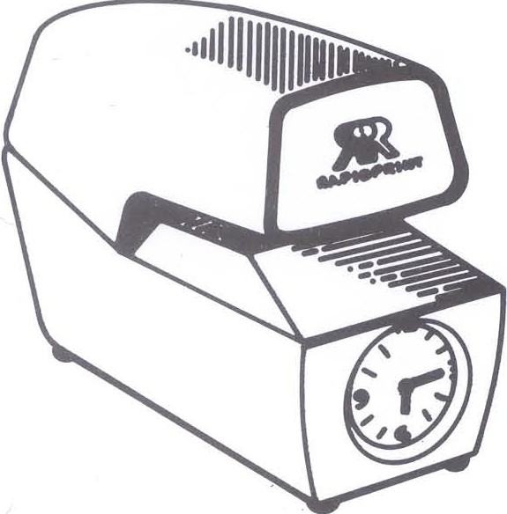

INSTRUCTION FOR SETTING ANALOG CLOCK
Set the hands to the proper time by using the setting wheel which protrudes from the bottom of the clock base.

3

DIGITAL CLOCK

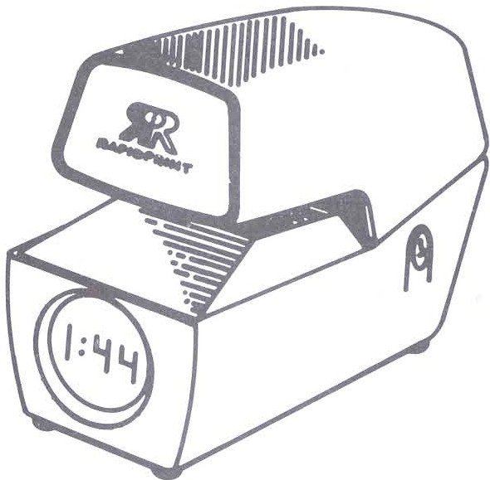

INSTRUCTIONS FOR SETTING DIGITAL CLOCK
- Press HOUR switch until correct hour is displayed.
- Press MIN. switch to advance to correct minute setting.

4

( Continued from Page 4)

To set the digital clock to the precise time, press the MIN. switch until the minutes display shows the current time. At the instant the minute advances on a reference clock, quickly press and release the MIN. switch.
The minutes will advance by one and seconds will be set to zero.

If a power failure has occurred, even for as brief a time as one second, upon restoration of power the display will flash at a 1 Hertz rate to indicate that the time displayed is incorrect.

5

HOW TO OBTAIN IMPRESSIONS

Insert the document to be printed between the top and bottom casting. When the leading edge of the paper engages the trigger, the machine will automati­ cally stamp. To get a straight impression, avoid putting the paper into the machine at an angle.

WARNING: DO NOT ATTEMPT TO STAMP anything

with paper clips, staples, etc-. in the area to be printed. This can cause serious damage to the printing wheels and/or die plates.

6

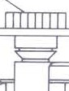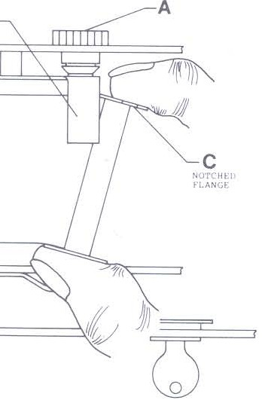
A
B
D

When ordering a new ribbon please refer to the part number 5650 and give the desired color. Purple is
the standard color. Other colors available are blue , I
red , black , or green.

7

TO REMOVE OLD RIBBON
Unplug machine from outlet. Unlock the machine and raise the top casting until it is fully open. Turn the machine sideways so that the lock is facing the operator.

Turn one of the ratchet wheels (A) one revolution to create slack in the ribbon. Lifting the ribbon feeler
(8) out of the way, place your index finger behind flange (C). Applying pressure towards operator, swing ribbon spool away (see diagram). Repeat operation for other side. Discard ribbon.

INSTALLING NEW RIBBON
Hold onto the ribbon spools so that notched flange
(C) faces ratchet wheel (A). Starting with spool closest to front of machine, insert flange (D) onto spring loaded stud. Lifting ribbon feeler, position notched flange (C) into place until spool is trapped between studs. (Rotating spool slightly may be necessary). Install remaining ribbon spool by slip­ ping ribbon under feeler (B) and repeating installa­ tion procedure. Turn one of the ratchet wheels (A) providing enough tension to flatten ribbon.

8

If your machine has a paper guide follow these installation instructions:
- Open the machine and remove the mounting screws with a medium sized Philips head screw­ driver. No other disassembly is required.
- Slide the paper plate and guide assembly under the ribbon mechanism as far back as possible. (If machine is outfitted with trigger extensions be sure not to bend these extensions when installing guide).

- Push down on the guide assembly and slide it forward so that the lip which extends out of the middle of the paper plate slides into the groove provided in the front of the machine casting.
- Line the holes in the paper plate and guide assembly with the holes in the center of the two mounting posts.
- Install mounting screws and tighten them down firmly. Your guide is now ready for operation.

9

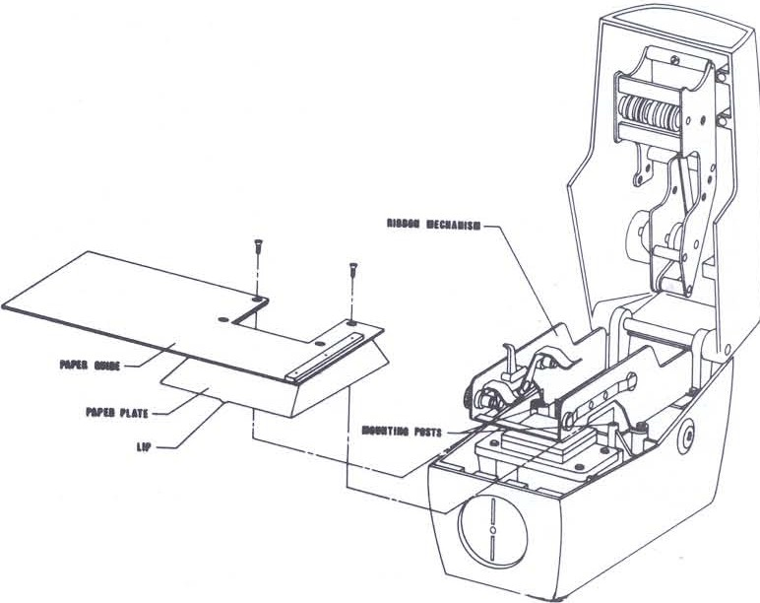

10

MAINTENANCE HINTS

Very little maintenance is necessary and, generally speaking, the nature of the machine is such that a qualified serviceman should be called in case the machine fails to operate. However, a few hints here.
BE SURE that the plug is fully inserted in the wall receptacle.
LUBRICATE moving metal parts regularly with a high grade business machine lubricant such as "Molykote G." Use only dry graphite on the printing plunger inside the solenoid coil. Avoid getting oil on the ribbon or any non-metallic or electrical part, and do not lubricate excessively. A drop or two is sufficient.
Remember to blow the dust out of your machine occasionally.
NEVER ATTEMPT to stamp over metallic objects such as staples and paper clips.
This machine has been preset at the factory. If the application changes contact your dealer.

11

\
..

RAPIDPRINT

